**CSCI 572 Assignment 4 – Indexing the Web using Solr**

**Web Pages Indexed – New York Post**

Name – Karthik Natarajan

USC ID – 5247024172

**STEP 1** – Downloaded Virtual Box version 5.2.0. Downloaded 64 bit version of Ubuntu Linux 16.04.5 LTS. Installed Virtual Box and started a new application for Linux and Ubuntu Version 64 bit. Used download Ubuntu Linux 16.04.5 LTS as virtual hard disk file. Followed the rest of the instructions for installing Ubuntu in the virtual machine. Set up a username and password for the virtual machine. However constant issues cropped up while adding Guest Additions to Ubuntu. After several fruitless efforts, continued with the rest of the assignment without adding the Guest Additions. There was no sharing of folders across the guest and host OS.

**STEP 2 –** After setting up Ubuntu, proceeded with installing Solr. Solr version 7.5.0 was downloaded and unpacked. Followed the instructions in the tutorial link provided to Index Techproducts Example Data. Once Solr was set up and working properly proceeded with the rest of the exercise. Once solr was installed, I just run it with the command : **$bin/solr start.** Solr’s UI can be viewed by going to the address <http://localhost:8983/solr> in the browser.

**STEP 3** – Learnt to use Solr to index a website. Started solr with command : **bin/solr start.** Created a new core called myexample using the command: **bin/solr create -c myexample.** After setting up myexample, I navigated to the conf folder of the newly created core and edited the ‘managed-schema’ file as per the instructions. I then proceeded to download the HTML pages of NY Post as per assignment instructions and indexed the HTML pages of NY Post using the command :

**$ bin/post -c myexample -filetypes html /home/karnat1802/Downloads/nypost/**

A total of 15403 files were indexed by Solr after issuing the above command.

**STEP 4 –** After having indexed the HTML pages the next step of the process was to go ahead with developing the UI for the assignment using PHP. After watching a few tutorials on Google was easily able to setup Apache Server and Php in Ubuntu to start developing the UI. Wrote a test.php file in /var/www/html/ folder with a simple print statement to see if php code was being rendered correctly by the Apache Server. On visiting <http://localhost/test.php> was able to see the php code working properly.

**STEP 5 –** First step in developing the UI was to work with the starter php code given in assignment description. As per assignment instructions download the solr-php-client from the given Github link in the assignment description and cloned the repository to /var/www/html/ folder. Modified the code to correctly point to the service.php file in the solr-php-client. Next, I proceeded with getting the Lucene results to display properly. Modified the starter php code to fetch only the relevant fields (title, og_url, og_description, id).Later on modified the php code to programmatically fetch the urls from the URLtoHTML.csv file.

**STEP 6 –** Once the Lucene results were being fetched and displayed correctly the next step was the get the PageRank results. First step towards doing that was the fetch the links from the web pages, and generate the edges file called edgesList.txt. Jsoup package was used in eclipse environment. Screenshot of the Java code along with the edgesList.txt is given below.

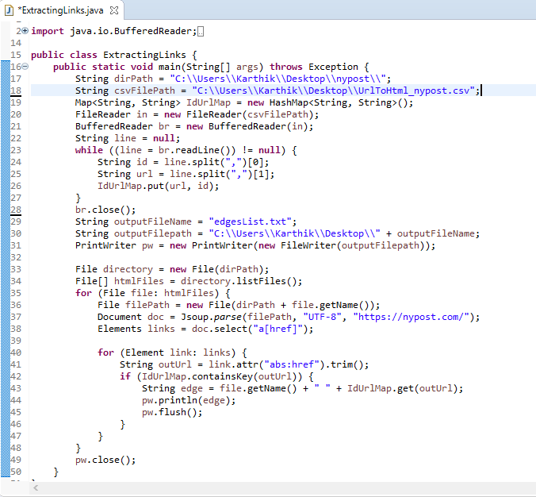

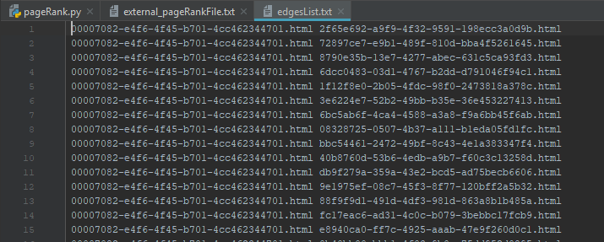

**STEP 7 –** After the edgeList.txt file has been generated the next step of the process is to compute the PageRank score of the html pages using the Network X library in Python. The pageRank scores for each website was store in the exter_PageRankFile.txt document. The python code was developed using the sample code given in the assignment instructions. The screenshots for both are given below.

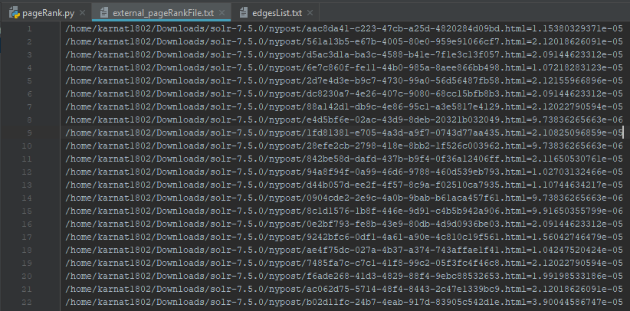

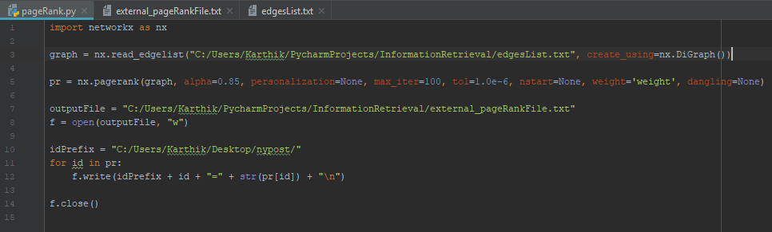

**STEP 8 –** Next step of the process is external_pageRankFile.txt in the data folder of the core. Then I went on to add the fields managed-schema and event listeners in the solrconfig.xml. Once these changes were done, the core was reloaded from the Solr UI. In the php file another parameter solr => pageRankFile.txt desc was added. Now the UI is ready to produce queries based on both default Lucene as well as the PageRank Algorithm.

**STEP 9 –** Compare the ranking algorithms for the queries. The detailed description for the ranking along with the screenshots for the queries are given below.

**EXPLANATION WHY SOME QUERIES HAS HIGHER PAGEARNK VALUES THAN OTHERS?**

Lucene ranking is based on Vector space model and Boolean model. It uses T-IDF and vector closeness to calculate the score for a webpage. On the other hand the PageRank uses the number of external links pointing to the webpage to determine its score. The edgesList file is generated to calculate the external pages pointing to a webpage. The more pages pointing to a given webpage the more will be its pageRank score. Each page has different number of webpages pointing to it and hence each webpage will have its own individual PageRank score.

Due the difference in both the strategies that are used by Lucene and PageRank the ranking of document produced by the queries are different.

**SCREENSHOTS**

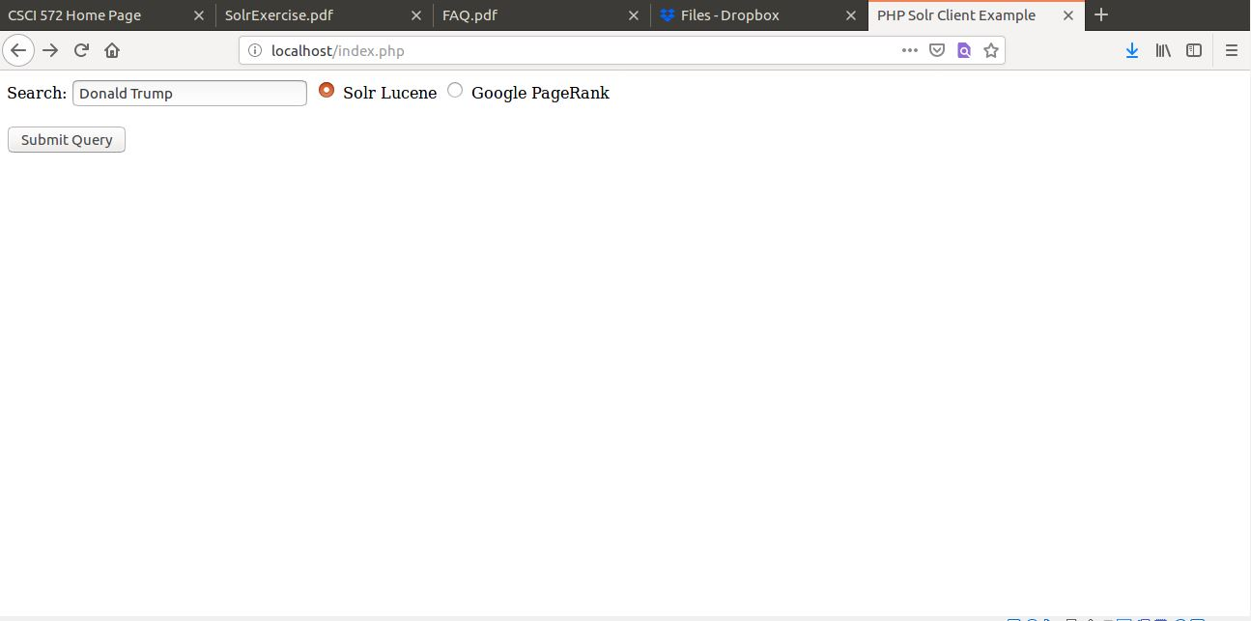Screenshot 1 : Initial Page where you insert the query

Screenshot 2: Screenshot of the page that shows for Lucene

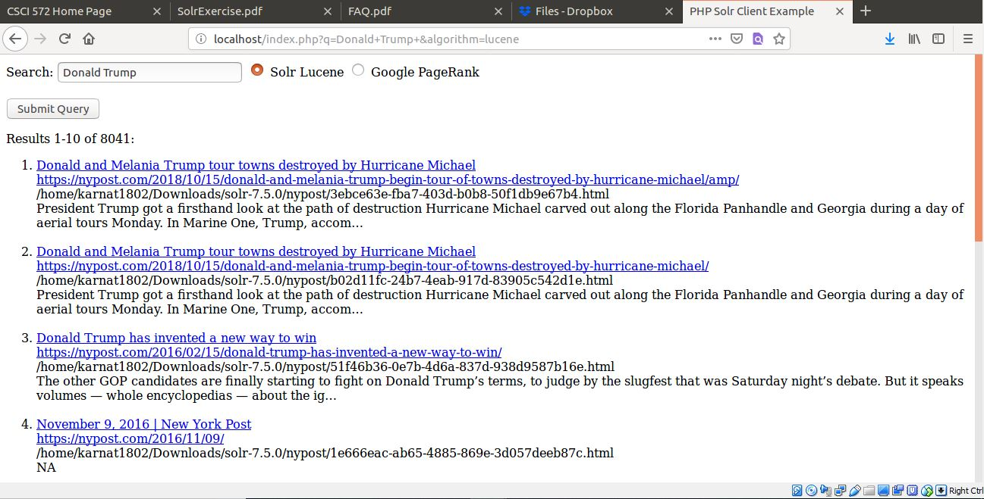

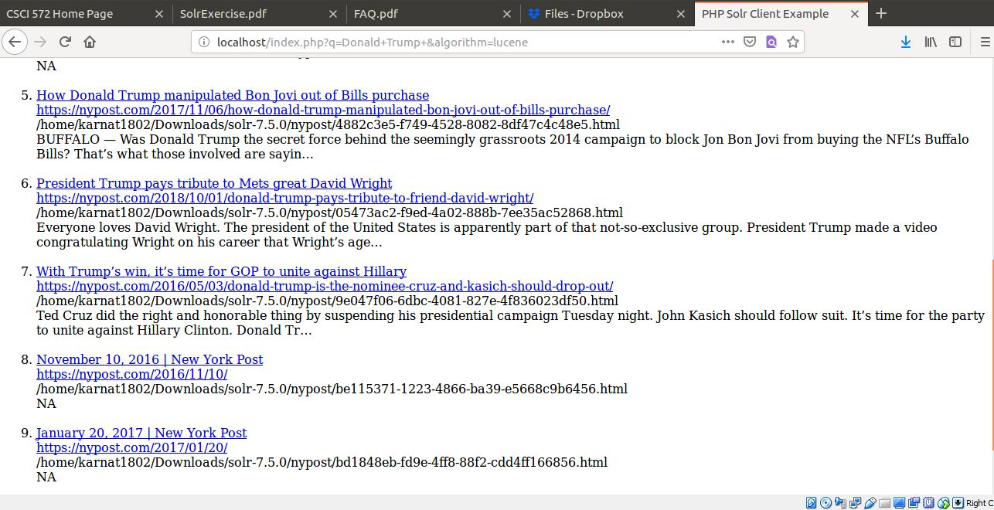

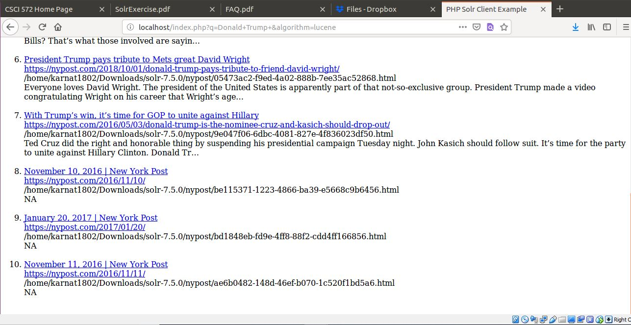

Screenshot 3: Screenshot of page which shows result for PageRank

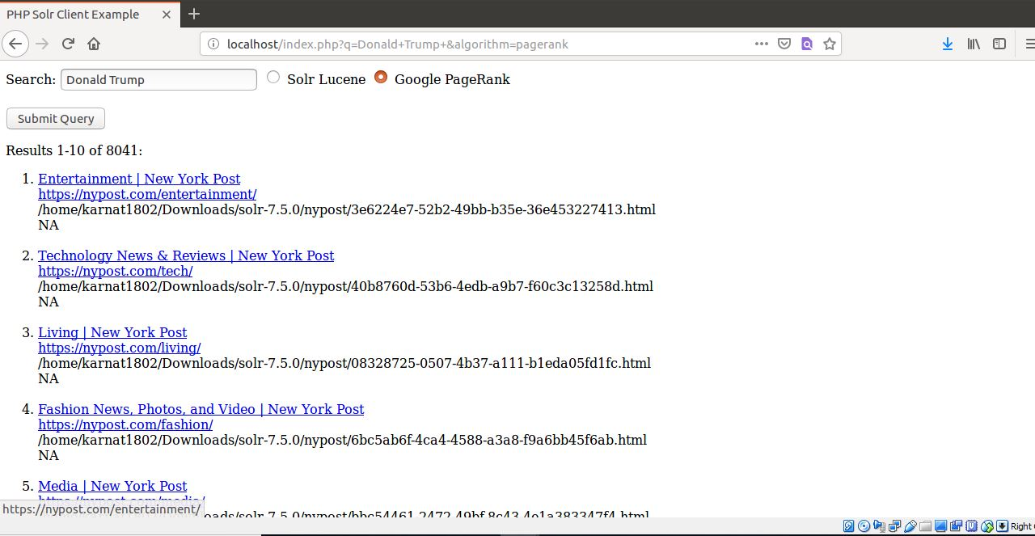

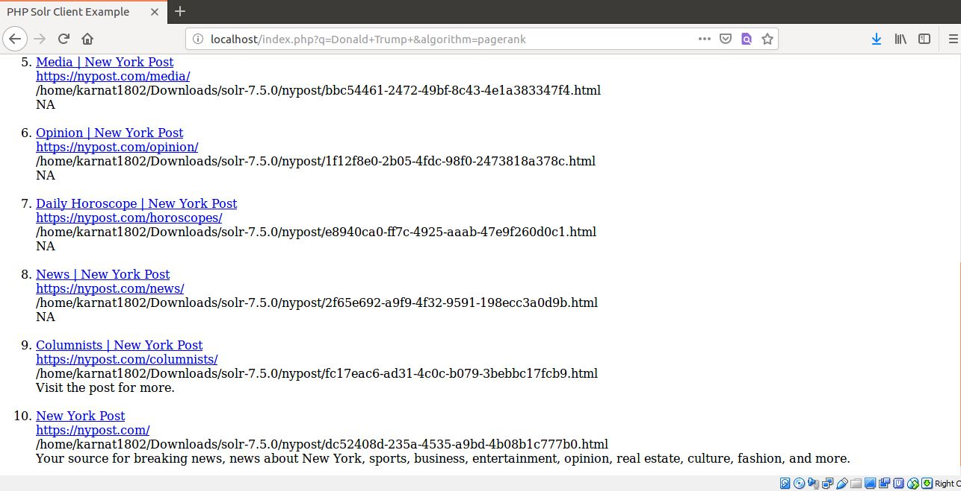

Screenshot 4: Screenshot of actual web page that opens up on clicking the url.

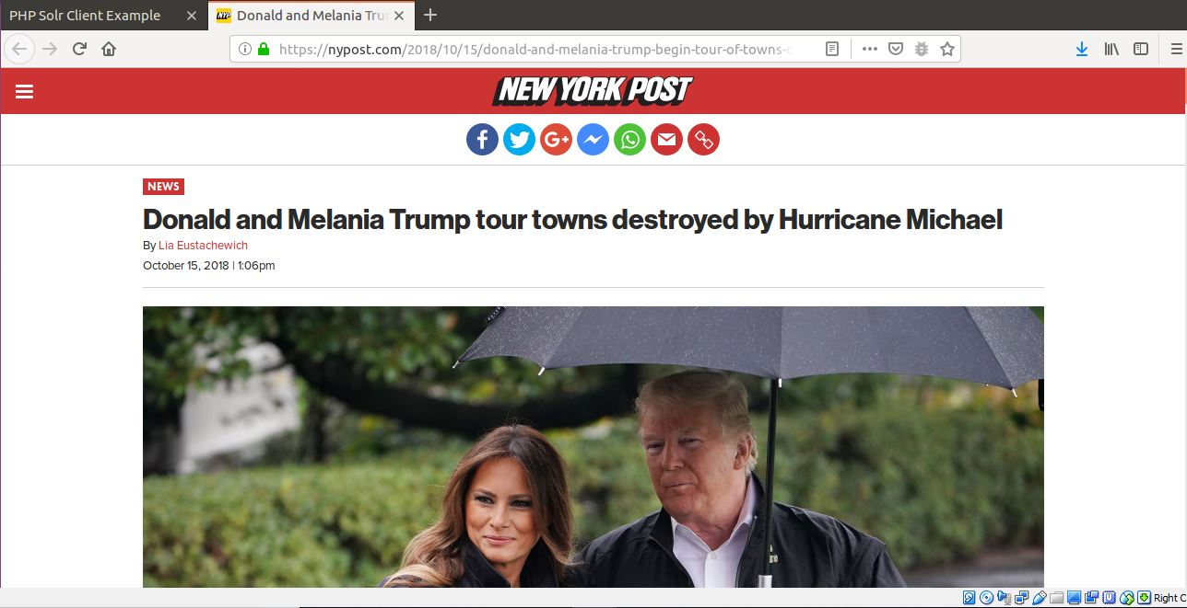

**QUERY COMPARISON**

**Query 1 : Donald Trump**

|  |  |  |
| --- | --- | --- |
| **Lucene** | **PageRank** | **Overlaps** |
| <https://nypost.com/2018/10/15/donald-and-melania-trump-begin-tour-of-towns-destroyed-by-hurricane-michael/amp/> | [**https://nypost.com/entertainment/**](https://nypost.com/entertainment/) | **0** |
| <https://nypost.com/2018/10/15/donald-and-melania-trump-begin-tour-of-towns-destroyed-by-hurricane-michael/> | [**https://nypost.com/tech/**](https://nypost.com/tech/) |
| <https://nypost.com/2016/02/15/donald-trump-has-invented-a-new-way-to-win/> | [**https://nypost.com/living/**](https://nypost.com/living/) |
| [**https://nypost.com/2016/11/09/**](https://nypost.com/2016/11/09/) | [**https://nypost.com/fashion/**](https://nypost.com/fashion/) |
| [**https://nypost.com/2017/11/06/how-donald-trump-manipulated-bon-jovi-out-of-bills-purchase/**](https://nypost.com/2017/11/06/how-donald-trump-manipulated-bon-jovi-out-of-bills-purchase/) | [**https://nypost.com/media/**](https://nypost.com/media/) |
| [**https://nypost.com/2018/10/01/donald-trump-pays-tribute-to-friend-david-wright/**](https://nypost.com/2018/10/01/donald-trump-pays-tribute-to-friend-david-wright/) | [**https://nypost.com/opinion/**](https://nypost.com/opinion/) |
| [**https://nypost.com/2016/05/03/donald-trump-is-the-nominee-cruz-and-kasich-should-drop-out/**](https://nypost.com/2016/05/03/donald-trump-is-the-nominee-cruz-and-kasich-should-drop-out/) | [**https://nypost.com/horoscopes/**](https://nypost.com/horoscopes/) |
| [**https://nypost.com/2016/11/10/**](https://nypost.com/2016/11/10/) | [**https://nypost.com/news/**](https://nypost.com/news/) |
| [**https://nypost.com/2017/01/20/**](https://nypost.com/2017/01/20/) | [**https://nypost.com/columnists/**](https://nypost.com/columnists/) |
| [**https://nypost.com/2016/11/11/**](https://nypost.com/2016/11/11/) | [**https://nypost.com/**](https://nypost.com/) |

**QUERY 2: LA Lakers**

|  |  |  |
| --- | --- | --- |
| **Lucene** | **PageRank** | **Overlaps** |
| <https://nypost.com/2018/09/25/lebron-james-knows-it-wont-come-easy-with-lakers/> | [**https://nypost.com/sports/**](https://nypost.com/sports/) | 0 |
| <https://nypost.com/2018/09/07/warriors-star-emerges-as-lakers-flashy-plan-b-in-free-agency/> | [**https://nypost.com/2018/10/15/tom-bradys-postgame-words-to-gronk-are-an-nfl-nightmare/**](https://nypost.com/2018/10/15/tom-bradys-postgame-words-to-gronk-are-an-nfl-nightmare/) |
| <https://nypost.com/2018/10/10/klay-thompson-gushes-over-lebron-as-lakers-pursuit-looms/> | [**https://nypost.com/2018/10/15/nfl-flameout-admits-to-having-sex-with-12-year-old-girl-police/**](https://nypost.com/2018/10/15/nfl-flameout-admits-to-having-sex-with-12-year-old-girl-police/) |
| [**https://nypost.com/tag/nba/**](https://nypost.com/tag/nba/) | [**https://nypost.com/2018/10/15/eli-manning-trade-could-save-him-and-the-giants-espn-qb/**](https://nypost.com/2018/10/15/eli-manning-trade-could-save-him-and-the-giants-espn-qb/) |
| [**https://nypost.com/tag/los-angeles-lakers/**](https://nypost.com/tag/los-angeles-lakers/) | [**https://nypost.com/2018/10/14/aaron-hernandez-had-sexual-relationship-with-hs-quarterback/**](https://nypost.com/2018/10/14/aaron-hernandez-had-sexual-relationship-with-hs-quarterback/) |
| [**https://nypost.com/2001/02/14/**](https://nypost.com/2001/02/14/) | [**https://nypost.com/2018/10/15/mlb-youngsters-bring-the-trash-talk-and-much-needed-fun/**](https://nypost.com/2018/10/15/mlb-youngsters-bring-the-trash-talk-and-much-needed-fun/) |
| [**https://nypost.com/2014/05/02/**](https://nypost.com/2014/05/02/) | [**https://nypost.com/2018/10/15/empty-vows-alderson-back-stab-inside-mets-gm-search-mess/**](https://nypost.com/2018/10/15/empty-vows-alderson-back-stab-inside-mets-gm-search-mess/) |
| [**https://nypost.com/2012/11/12/**](https://nypost.com/2012/11/12/) | [**https://nypost.com/2018/10/15/angry-about-the-subways-send-cuomo-a-message/**](https://nypost.com/2018/10/15/angry-about-the-subways-send-cuomo-a-message/) |
| [**https://nypost.com/2015/06/26/**](https://nypost.com/2015/06/26/) | [**https://nypost.com/2018/10/15/a-giants-trade-for-ex-patriots-quarterback-would-make-sense/**](https://nypost.com/2018/10/15/a-giants-trade-for-ex-patriots-quarterback-would-make-sense/) |
| [**https://nypost.com/2017/02/21/**](https://nypost.com/2017/02/21/) | [**https://nypost.com/2018/10/15/how-one-veterans-vietnam-horrors-inspired-this-is-us/**](https://nypost.com/2018/10/15/how-one-veterans-vietnam-horrors-inspired-this-is-us/) |

**QUERY 3: Star Wars**

|  |  |  |
| --- | --- | --- |
| **Lucene** | **PageRank** | **Overlaps** |
| <https://nypost.com/2015/12/18/> | [**https://nypost.com/entertainment/**](https://nypost.com/entertainment/) | **0** |
| <https://nypost.com/2015/12/15/> | [**https://nypost.com/sports/**](https://nypost.com/sports/) |
| <https://nypost.com/2015/12/17/> | [**https://nypost.com/metro/**](https://nypost.com/metro/) |
| [**https://nypost.com/2015/12/16/**](https://nypost.com/2015/12/16/) | [**https://nypost.com/tech/**](https://nypost.com/tech/) |
| [**https://nypost.com/2015/12/22/**](https://nypost.com/2015/12/22/) | [**https://nypost.com/living/**](https://nypost.com/living/) |
| [**https://nypost.com/2015/12/14/**](https://nypost.com/2015/12/14/) | [**https://nypost.com/fashion/**](https://nypost.com/fashion/) |
| [**https://nypost.com/2015/11/24/**](https://nypost.com/2015/11/24/) | [**https://nypost.com/media/**](https://nypost.com/media/) |
| [**https://nypost.com/2015/04/20/**](https://nypost.com/2015/04/20/) | [**https://nypost.com/real-estate/**](https://nypost.com/real-estate/) |
| [**https://nypost.com/2015/10/20/**](https://nypost.com/2015/10/20/) | [**https://nypost.com/photos/**](https://nypost.com/photos/) |
| [**https://nypost.com/2015/04/16/**](https://nypost.com/2015/04/16/) | [**https://nypost.com/horoscopes/**](https://nypost.com/horoscopes/) |

**QUERY 4: Lebron James**

|  |  |  |
| --- | --- | --- |
| **Lucene** | **PageRank** | **Overlaps** |
| <https://nypost.com/2018/09/25/lebron-james-knows-it-wont-come-easy-with-lakers/> | [**https://nypost.com/sports/**](https://nypost.com/sports/) | 0 |
| <https://nypost.com/2018/04/04/lebron-saban-feud-over-shop-talk-show-in-copyright-dispute/> | [**https://nypost.com/metro/**](https://nypost.com/metro/) |
| <https://nypost.com/tag/los-angeles-lakers/> | [**https://nypost.com/2018/10/13/100m-cybersecurity-center-slated-to-open-in-soho-next-year/**](https://nypost.com/2018/10/13/100m-cybersecurity-center-slated-to-open-in-soho-next-year/) |
| [**https://nypost.com/2010/07/09/**](https://nypost.com/2010/07/09/) | [**https://nypost.com/2018/10/15/judge-tosses-stormy-daniels-defamation-suit-against-trump/**](https://nypost.com/2018/10/15/judge-tosses-stormy-daniels-defamation-suit-against-trump/) |
| [**https://nypost.com/2018/07/02/**](https://nypost.com/2018/07/02/) | [**https://nypost.com/2018/10/15/beach-house-still-standing-after-hurricane-michael-devastates-nearby-homes/**](https://nypost.com/2018/10/15/beach-house-still-standing-after-hurricane-michael-devastates-nearby-homes/) |
| [**https://nypost.com/2018/10/10/klay-thompson-gushes-over-lebron-as-lakers-pursuit-looms/**](https://nypost.com/2018/10/10/klay-thompson-gushes-over-lebron-as-lakers-pursuit-looms/) | [**https://nypost.com/2018/10/15/ex-nightlife-king-plans-to-open-a-private-club-in-noho/**](https://nypost.com/2018/10/15/ex-nightlife-king-plans-to-open-a-private-club-in-noho/) |
| [**https://nypost.com/2010/07/08/**](https://nypost.com/2010/07/08/) | [**https://nypost.com/2018/10/15/nyc-goes-entire-weekend-without-a-shooting-for-first-time-in-14-years/**](https://nypost.com/2018/10/15/nyc-goes-entire-weekend-without-a-shooting-for-first-time-in-14-years/) |
| [**https://nypost.com/2014/07/11/**](https://nypost.com/2014/07/11/) | [**https://nypost.com/2018/10/15/new-york-city-restaurant-scene-teeming-with-new-entries/**](https://nypost.com/2018/10/15/new-york-city-restaurant-scene-teeming-with-new-entries/) |
| [**https://nypost.com/2010/07/01/**](https://nypost.com/2010/07/01/) | [**https://nypost.com/2018/10/15/knicks-season-preview-what-theyre-really-playing-for/**](https://nypost.com/2018/10/15/knicks-season-preview-what-theyre-really-playing-for/) |
| [**https://nypost.com/2010/07/07/**](https://nypost.com/2010/07/07/) | [**https://nypost.com/2018/10/12/little-kids-are-wearing-grown-up-makeup-is-it-ok/**](https://nypost.com/2018/10/12/little-kids-are-wearing-grown-up-makeup-is-it-ok/) |

**QUERY 5: 2018 World Cup**

|  |  |  |
| --- | --- | --- |
| **Lucene** | **PageRank** | **Overlaps** |
| <https://nypost.com/2018/07/12/theres-a-knicks-battle-and-bet-over-the-world-cup-final/> | [**https://nypost.com/entertainment/**](https://nypost.com/entertainment/) | **0** |
| <https://nypost.com/video/this-psychic-pig-just-predicted-the-world-cup/> | [**https://nypost.com/sports/**](https://nypost.com/sports/) |
| <https://nypost.com/2018/06/05/nycfc-cant-wait-to-get-monkey-off-their-back-in-u-s-open-cup/> | [**https://nypost.com/tips/**](https://nypost.com/tips/) |
| [**https://nypost.com/2018/10/04/stricken-ryder-cup-fan-i-thought-id-be-trampled-by-tiger-woods-fans/**](https://nypost.com/2018/10/04/stricken-ryder-cup-fan-i-thought-id-be-trampled-by-tiger-woods-fans/) | [**https://nypost.com/metro/**](https://nypost.com/metro/) |
| [**https://nypost.com/2018/07/13/son-of-stanley-cup-winning-devil-chasing-nhl-dream/**](https://nypost.com/2018/07/13/son-of-stanley-cup-winning-devil-chasing-nhl-dream/) | [**https://nypost.com/tech/**](https://nypost.com/tech/) |
| [**https://nypost.com/2014/06/12/**](https://nypost.com/2014/06/12/) | [**https://nypost.com/living/**](https://nypost.com/living/) |
| [**https://nypost.com/2014/06/11/**](https://nypost.com/2014/06/11/) | [**https://nypost.com/mobile-apps/**](https://nypost.com/mobile-apps/) |
| [**https://nypost.com/2018/10/04/capitals-stanley-cup-tribute-was-a-little-bit-petty/**](https://nypost.com/2018/10/04/capitals-stanley-cup-tribute-was-a-little-bit-petty/) | [**https://nypost.com/fashion/**](https://nypost.com/fashion/) |
| [**https://nypost.com/2018/10/02/nhl-preview-these-stanley-cup-contenders-are-racing-the-clock/amp/**](https://nypost.com/2018/10/02/nhl-preview-these-stanley-cup-contenders-are-racing-the-clock/amp/) | [**https://nypost.com/media/**](https://nypost.com/media/) |
| [**https://nypost.com/tag/tiger-woods/**](https://nypost.com/tag/tiger-woods/) | [**https://nypost.com/real-estate/**](https://nypost.com/real-estate/) |

**QUERY 6: North Korea**

|  |  |  |
| --- | --- | --- |
| **Lucene** | **PageRank** | **Overlaps** |
| <https://nypost.com/2018/08/30/a-glimpse-at-life-inside-north-korea/slide-1/> | [**https://nypost.com/real-estate/**](https://nypost.com/real-estate/) | **0** |
| <https://nypost.com/2018/08/24/state-department-reportedly-blindsided-by-trump-canceling-north-korea-trip/> | [**https://nypost.com/2018/10/15/tom-bradys-postgame-words-to-gronk-are-an-nfl-nightmare/**](https://nypost.com/2018/10/15/tom-bradys-postgame-words-to-gronk-are-an-nfl-nightmare/) |
| <https://nypost.com/2018/06/07/former-pow-calls-on-trump-to-reclaim-us-ship-captured-by-north-korea/> | [**https://nypost.com/2018/10/15/nfl-flameout-admits-to-having-sex-with-12-year-old-girl-police/**](https://nypost.com/2018/10/15/nfl-flameout-admits-to-having-sex-with-12-year-old-girl-police/) |
| [**https://nypost.com/2018/10/07/pompeo-progress-made-with-kim-jong-un-on-north-korea-trip/**](https://nypost.com/2018/10/07/pompeo-progress-made-with-kim-jong-un-on-north-korea-trip/) | [**https://nypost.com/2018/10/15/eli-manning-trade-could-save-him-and-the-giants-espn-qb/**](https://nypost.com/2018/10/15/eli-manning-trade-could-save-him-and-the-giants-espn-qb/) |
| [**https://nypost.com/2018/09/10/north-korea-marks-the-hermit-kingdoms-70th-anniversary/slide-1/**](https://nypost.com/2018/09/10/north-korea-marks-the-hermit-kingdoms-70th-anniversary/slide-1/) | [**https://nypost.com/2018/10/14/aaron-hernandez-had-sexual-relationship-with-hs-quarterback/**](https://nypost.com/2018/10/14/aaron-hernandez-had-sexual-relationship-with-hs-quarterback/) |
| [**https://nypost.com/2017/09/09/how-democrats-left-america-naked-before-north-koreas-nukes/**](https://nypost.com/2017/09/09/how-democrats-left-america-naked-before-north-koreas-nukes/) | [**https://nypost.com/2018/10/15/mlb-youngsters-bring-the-trash-talk-and-much-needed-fun/**](https://nypost.com/2018/10/15/mlb-youngsters-bring-the-trash-talk-and-much-needed-fun/) |
| [**https://nypost.com/2017/09/03/**](https://nypost.com/2017/09/03/) | [**https://nypost.com/2018/10/15/empty-vows-alderson-back-stab-inside-mets-gm-search-mess/**](https://nypost.com/2018/10/15/empty-vows-alderson-back-stab-inside-mets-gm-search-mess/) |
| [**https://nypost.com/2018/10/02/trumps-love-for-kim-is-undercutting-his-own-teams-necessary-toughness/**](https://nypost.com/2018/10/02/trumps-love-for-kim-is-undercutting-his-own-teams-necessary-toughness/) | [**https://nypost.com/2018/10/15/how-eddie-lampert-led-sears-into-bankruptcy-disaster/**](https://nypost.com/2018/10/15/how-eddie-lampert-led-sears-into-bankruptcy-disaster/) |
| [**https://nypost.com/2017/09/04/**](https://nypost.com/2017/09/04/) | [**https://nypost.com/2018/10/15/the-south-bronx-is-in-the-midst-of-a-development-boom/**](https://nypost.com/2018/10/15/the-south-bronx-is-in-the-midst-of-a-development-boom/) |
| [**https://nypost.com/2018/10/04/north-korean-hackers-linked-to-global-banking-heist/**](https://nypost.com/2018/10/04/north-korean-hackers-linked-to-global-banking-heist/) |  |

**QUERY 7: Hurricane Florence**

|  |  |  |
| --- | --- | --- |
| **Lucene** [**https://nypost.com/2018/09/15/kitten-named-survivor-rescued-with-owner-from-hurricane-florence/**](https://nypost.com/2018/09/15/kitten-named-survivor-rescued-with-owner-from-hurricane-florence/) | **PageRank** | **Overlaps** |
| <https://nypost.com/2018/09/14/hurricane-florence-storms-north-carolina/slide-1/> | [**https://nypost.com/real-estate/**](https://nypost.com/real-estate/) | **0** |
| <https://nypost.com/2018/09/11/the-carolinas-brace-for-hurricane-florence/slide-1/> | [**https://nypost.com/photos/**](https://nypost.com/photos/) |
| <https://nypost.com/2018/09/13/hurricane-florence-closes-in-on-carolina-coast/> | [**https://nypost.com/news/**](https://nypost.com/news/) |
| [**https://nypost.com/2018/09/10/hurricane-florence-looks-wild-from-the-international-space-station/**](https://nypost.com/2018/09/10/hurricane-florence-looks-wild-from-the-international-space-station/) | [**https://nypost.com/2018/10/15/surveillance-video-shows-moment-before-model-shot-in-neck-crashes-car/**](https://nypost.com/2018/10/15/surveillance-video-shows-moment-before-model-shot-in-neck-crashes-car/) |
| [**https://nypost.com/2018/09/20/unc-football-players-lend-hand-to-hurricane-florence-victims/**](https://nypost.com/2018/09/20/unc-football-players-lend-hand-to-hurricane-florence-victims/) | [**https://nypost.com/2018/10/15/beach-house-still-standing-after-hurricane-michael-devastates-nearby-homes/**](https://nypost.com/2018/10/15/beach-house-still-standing-after-hurricane-michael-devastates-nearby-homes/) |
| [**https://nypost.com/2018/09/14/astronaut-snaps-picture-of-hurricane-florence-as-it-makes-landfall/**](https://nypost.com/2018/09/14/astronaut-snaps-picture-of-hurricane-florence-as-it-makes-landfall/) | [**https://nypost.com/2018/10/15/ex-nightlife-king-plans-to-open-a-private-club-in-noho/**](https://nypost.com/2018/10/15/ex-nightlife-king-plans-to-open-a-private-club-in-noho/) |
| [**https://nypost.com/2018/09/24/hurricane-florence-isnt-done-with-the-carolinas-just-yet/**](https://nypost.com/2018/09/24/hurricane-florence-isnt-done-with-the-carolinas-just-yet/) | [**https://nypost.com/2018/10/15/sears-death-of-an-american-icon/slide-1/**](https://nypost.com/2018/10/15/sears-death-of-an-american-icon/slide-1/) |
| [**https://nypost.com/2018/09/19/north-carolina-hog-lagoons-are-exploding-poo-after-hurricane-florence/**](https://nypost.com/2018/09/19/north-carolina-hog-lagoons-are-exploding-poo-after-hurricane-florence/) | [**https://nypost.com/2018/10/15/heres-what-elizabeth-warrens-dna-test-shows/**](https://nypost.com/2018/10/15/heres-what-elizabeth-warrens-dna-test-shows/) |
| [**https://nypost.com/tag/hurricanes/page/2/**](https://nypost.com/tag/hurricanes/page/2/) | [**https://nypost.com/2018/10/11/michael-leaves-florida-panhandle-in-shambles/slide-1/**](https://nypost.com/2018/10/11/michael-leaves-florida-panhandle-in-shambles/slide-1/) |
| [**https://nypost.com/2018/09/15/kitten-named-survivor-rescued-with-owner-from-hurricane-florence/**](https://nypost.com/2018/09/15/kitten-named-survivor-rescued-with-owner-from-hurricane-florence/) | [**https://nypost.com/2018/10/10/hurricane-michael-starts-pounding-the-florida-panhandle/slide-1/**](https://nypost.com/2018/10/10/hurricane-michael-starts-pounding-the-florida-panhandle/slide-1/) |

**QUERY 8: Paul Allen**

|  |  |  |
| --- | --- | --- |
| **Lucene** | **PageRank** | **Overlaps** |
| <https://nypost.com/2018/10/15/microsoft-co-founder-paul-allen-dead-at-65/amp/> | [**https://nypost.com/sports/**](https://nypost.com/sports/) | **2** |
| <https://nypost.com/2018/10/15/microsoft-co-founder-paul-allen-dead-at-65/?shared=email&msg=fail> | [**https://nypost.com/tech/**](https://nypost.com/tech/) |
| <https://nypost.com/2018/10/15/microsoft-co-founder-paul-allen-dead-at-65/?shared=email&msg=fail> | [**https://nypost.com/news/**](https://nypost.com/news/) |
| [**https://nypost.com/tag/paul-allen/**](https://nypost.com/tag/paul-allen/) | [**https://nypost.com/columnists/**](https://nypost.com/columnists/) |
| [**https://nypost.com/2018/03/06/microsoft-co-founder-finds-long-lost-wwii-aircraft-carrier/amp/**](https://nypost.com/2018/03/06/microsoft-co-founder-finds-long-lost-wwii-aircraft-carrier/amp/) | [**https://nypost.com/**](https://nypost.com/) |
| [**https://nypost.com/author/carleton-english/**](https://nypost.com/author/carleton-english/) | [**https://nypost.com/2018/10/15/microsoft-co-founder-paul-allen-dead-at-65/**](https://nypost.com/2018/10/15/microsoft-co-founder-paul-allen-dead-at-65/) |
| [**https://nypost.com/tech/page/2/**](https://nypost.com/tech/page/2/) | [**https://nypost.com/2018/10/15/worlds-youngest-male-billionaire-is-25-year-old-model/**](https://nypost.com/2018/10/15/worlds-youngest-male-billionaire-is-25-year-old-model/) |
| [**https://nypost.com/tech/page/3/**](https://nypost.com/tech/page/3/) | [**https://nypost.com/2018/10/15/sears-death-of-an-american-icon/slide-1/**](https://nypost.com/2018/10/15/sears-death-of-an-american-icon/slide-1/) |
| [**https://nypost.com/tech/**](https://nypost.com/tech/) | [**https://nypost.com/2018/10/15/state-department-sends-out-email-featuring-cookie-monster-cat/**](https://nypost.com/2018/10/15/state-department-sends-out-email-featuring-cookie-monster-cat/) |
| [**https://nypost.com/2018/03/06/microsoft-co-founder-finds-long-lost-wwii-aircraft-carrier/amp/**](https://nypost.com/2018/03/06/microsoft-co-founder-finds-long-lost-wwii-aircraft-carrier/amp/) | [**https://nypost.com/2018/10/15/de-blasios-nycha-strategy-was-deceptive-from-the-start/**](https://nypost.com/2018/10/15/de-blasios-nycha-strategy-was-deceptive-from-the-start/) |

**Overlap Graph**

**END OF REPORT**